**Object Oriented Analysis and Design using Java**

**Week 1 Lab Assignment**

|  |  |  |  |
| --- | --- | --- | --- |
| Vanshika Goel | PES1UG20CS484 | Section H | Roll No 40 |

**Problem Statement**

**Identify the use cases and actors and their relationships for Unique Identification Number System and depict it with a Use Case diagram:**

UID Number Automation System: To simplify the process of applying for a UID Number, a software system has to be created. Initially the applicant will login to the UIDN system and book an appointment to visit the local UIDN centre. The official at UIDN centre, on verifying the appointment, uploads the documents and biometrics of the applicant to the system. The backend officials then verify the documents and approve application which results in an UID number being assigned to the applicant. After the UID number is assigned, the backend official will print and dispatch the UIDN card to the applicant. The official can send an e-copy of the card to the cardholder if he/she has requested for the same in the application. At any time after receiving the card, the card holder can request update to their details in the system. For details other than biometric, the card holder themselves can upload the required documents on the system, which will then be processed by backend officials and new card with updated details is issued. For biometric details update, the card holder has to take an appointment to visit the local UIDN centre. The official at the centre then initiate update to biometric details. Any third-party organization can request authentication of the user in two ways. 1. Given an UID number, fetch basic details like Name, Age, and Gender etc. 2. Given a biometric fingerprint, fetch the last four digits of the UID number along with the Name.

1. **Actors and Usecases**

|  |  |  |
| --- | --- | --- |
| **Actors** | **Usecases** | **Relationships** |
| Applicant | Log in to UIDN system | <<include>> Verify Details |
| UIDN official | Book appointment |  |
| Backend Officials | Verify Appointment Details at centre |  |
| Third-Party Organisation | Upload Documents and Biometrics |  |
| Cardholder | Verify Documents Uploaded |  |
|  | Approve Application | <<include>> Assign UID number <<include>> Print and Dispatch UID Card, <<exclude>> Reject Application |
|  | Send E-copy of Card if requested |  |
|  | Request Update of Details |  |
|  | Upload Required Documents |  |
|  | Verify New Details |  |
|  | Update New Details | <<include>> New Card Issued |
|  | Request Update of Biometrics | <<include>> Make Appointment for Biometrics Update |
|  | Update Biometrics for Applicant |  |
|  | Request for Authentication of User | <<include> UID Number of User, <<include>> Biometric fingerprint |
|  | Fetch details like Name, Age, Gender of requested User |  |
|  | Fetch details like last 4 digits of UID Number and Name |  |

**UseCase Diagram**

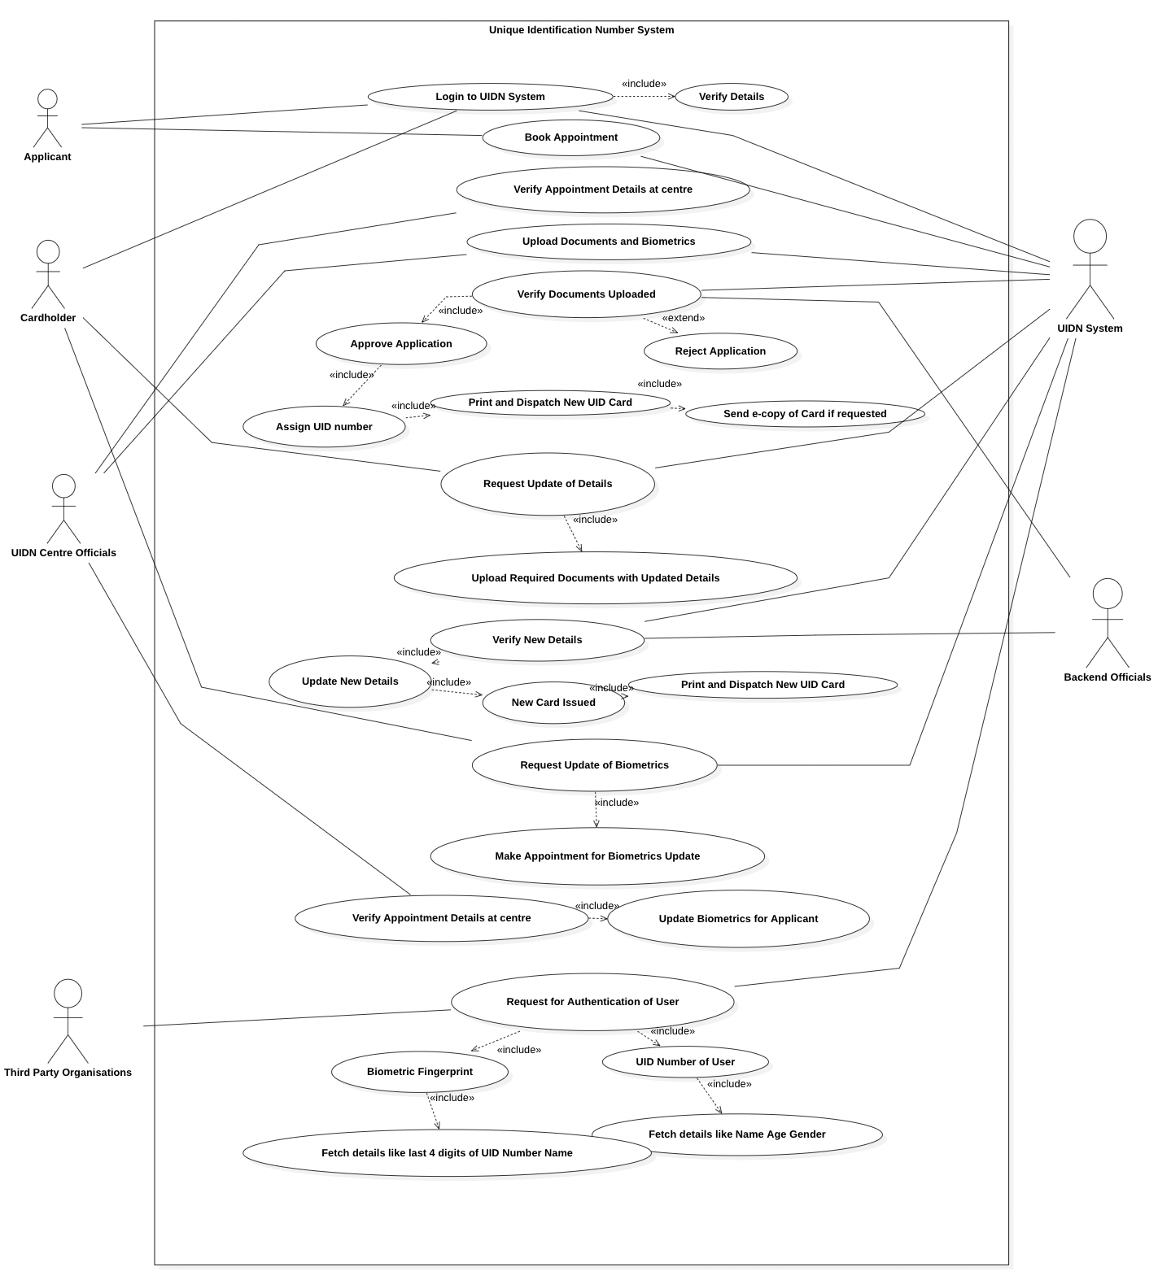

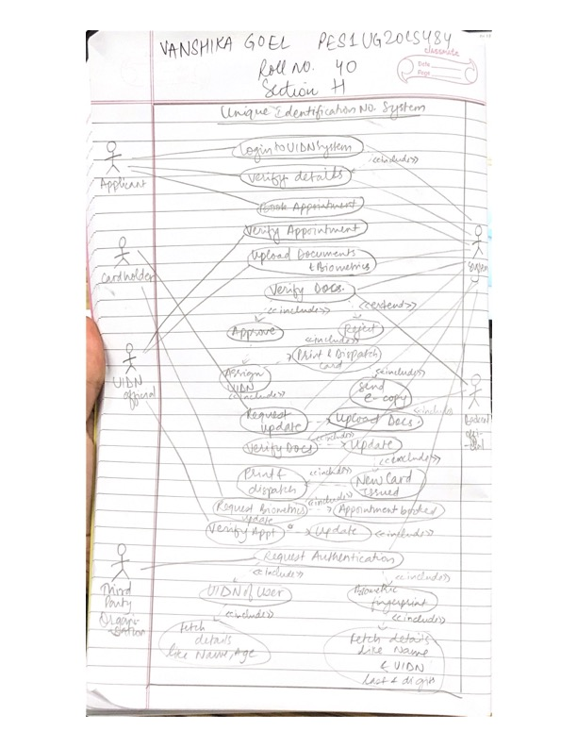

**Use Case Specification**

**(2)**

**1.**

Name: Request Update of Details (except Biometrics)

Summary/Overview: Request update of details after card is received

Actor: Cardholder

Pre-conditions: The user needs to be a cardholder and have documents for the new details.

Description:

1. The user can make request for upload of new details and upload the documents.
2. The documents will be verified, and new card will be issued.

Exceptions:

* In case documents uploaded are wrong, then request for update will be rejected.

Alternate Flows:

* If documents are wrong or redundant, then the documents will be processed according to requirements.

**2.**

Name: Verify Documents Uploaded

Summary/Overview: Verification of Documents Uploaded by the UIDN Official for Approval/Rejection of Card

Actor: Backend Official

Pre-conditions: The user needs to come to the UIDN Centre for Documents Upload and Biometrics Upload

Description:

1. Backend officials checks for all documents and makes sures that the documents are correct
2. Ensures that the biometrics done are clear and visible
3. Approve the card if the above conditions are met, else Reject the application for a UIDN Card

Exceptions:

* In case card is rejected, all reasons for rejection are mentioned

Alternate Flows:

* If the request for card is made by a user who already has a card, the user is sent a copy of the old card.